**DAILY ONLINE ACTIVITIES SUMMARY**

|  |  |  |  |  |  |  |  |
| --- | --- | --- | --- | --- | --- | --- | --- |
| **Date:** | **20/05/2020** | | | | **Name:** | **AMRUTHA G** | |
| **Sem & Sec** | **4&A** | | | | **USN:** | **4AL18CS006** | |
| **Online Test Summary** | | | | | | | |
| **Subject** | | **OBJECT ORIENTED CONCEPTS(18CS43)** | | | | | |
| **Max. Marks** | | **30** | | **Score** | | **13** | |
| **Certification Course Summary** | | | | | | | |
| **Course** | **1.JAVA PROGRAMMING**  **2.PYTHON FOR MACHINE LEARNING** | | | | | | |
| **Certificate Provider** | | | **Great learning academy** | **Duration** | | | **3.5**  **3.5** |
| **Coding Challenges** | | | | | | | |
| **Problem Statement1: To find the palindrome in java** | | | | | | | |
| **Status:executed** | | | | | | | |
| **Uploaded the report in Github** | | | | **YES** | | | |
| **If yes Repository name** | | | | **https://github.com/AMRUTHAGANESH/lockdown-certification_course** | | | |
| **Uploaded the report in slack** | | | | **YES** | | | |

Online Test Details:18CS43(OOC)

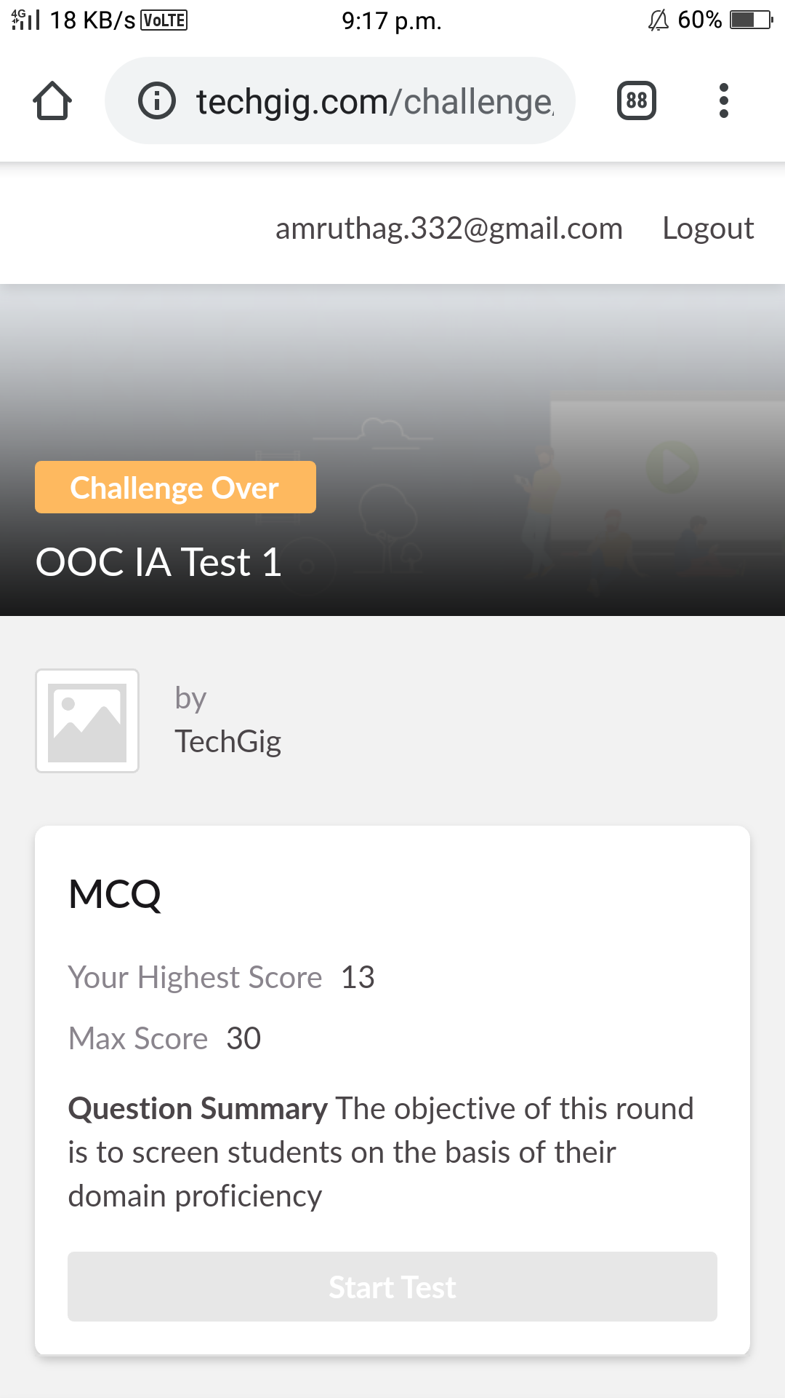

Certification Course Details

I have opted my Online Certification Course In great learning the course which opted is PYTHON FOR MACHINE LEARNING This course contains assessments and practice assessments

Today I started python for machine learning

The topics covered under Python for Machine Learning are

1.NumPy Introduction-2

2.Saving and Loading NumPy Array-2

3.Pandas -Introduction-2

4.Pandas-Series and Dataframes-2

5.Pandas-Accessing and Modifying-2

6.Pandas-Combining Dataframes-2

7.Pandas-Functions-2

8.Pandas-Saving and Loading Dataframes-2

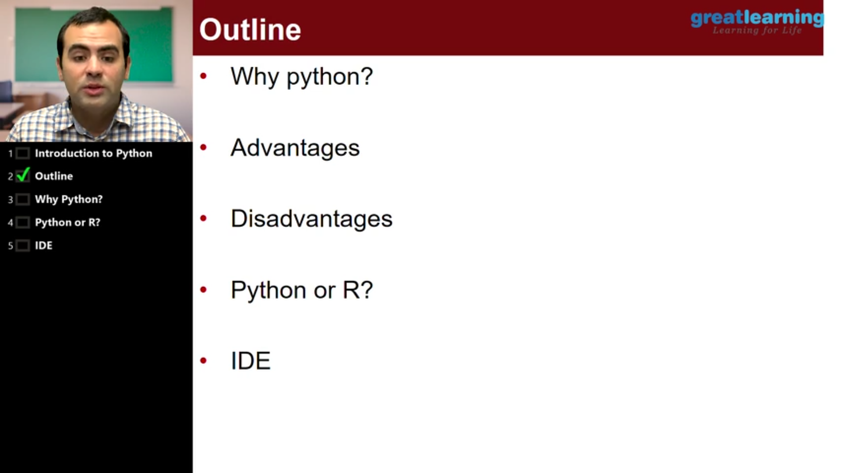

Coding Challenges Details: The program is to find the palindrome in java

